10pF coupling capacitor between DDS and buffer.
1.838MHz
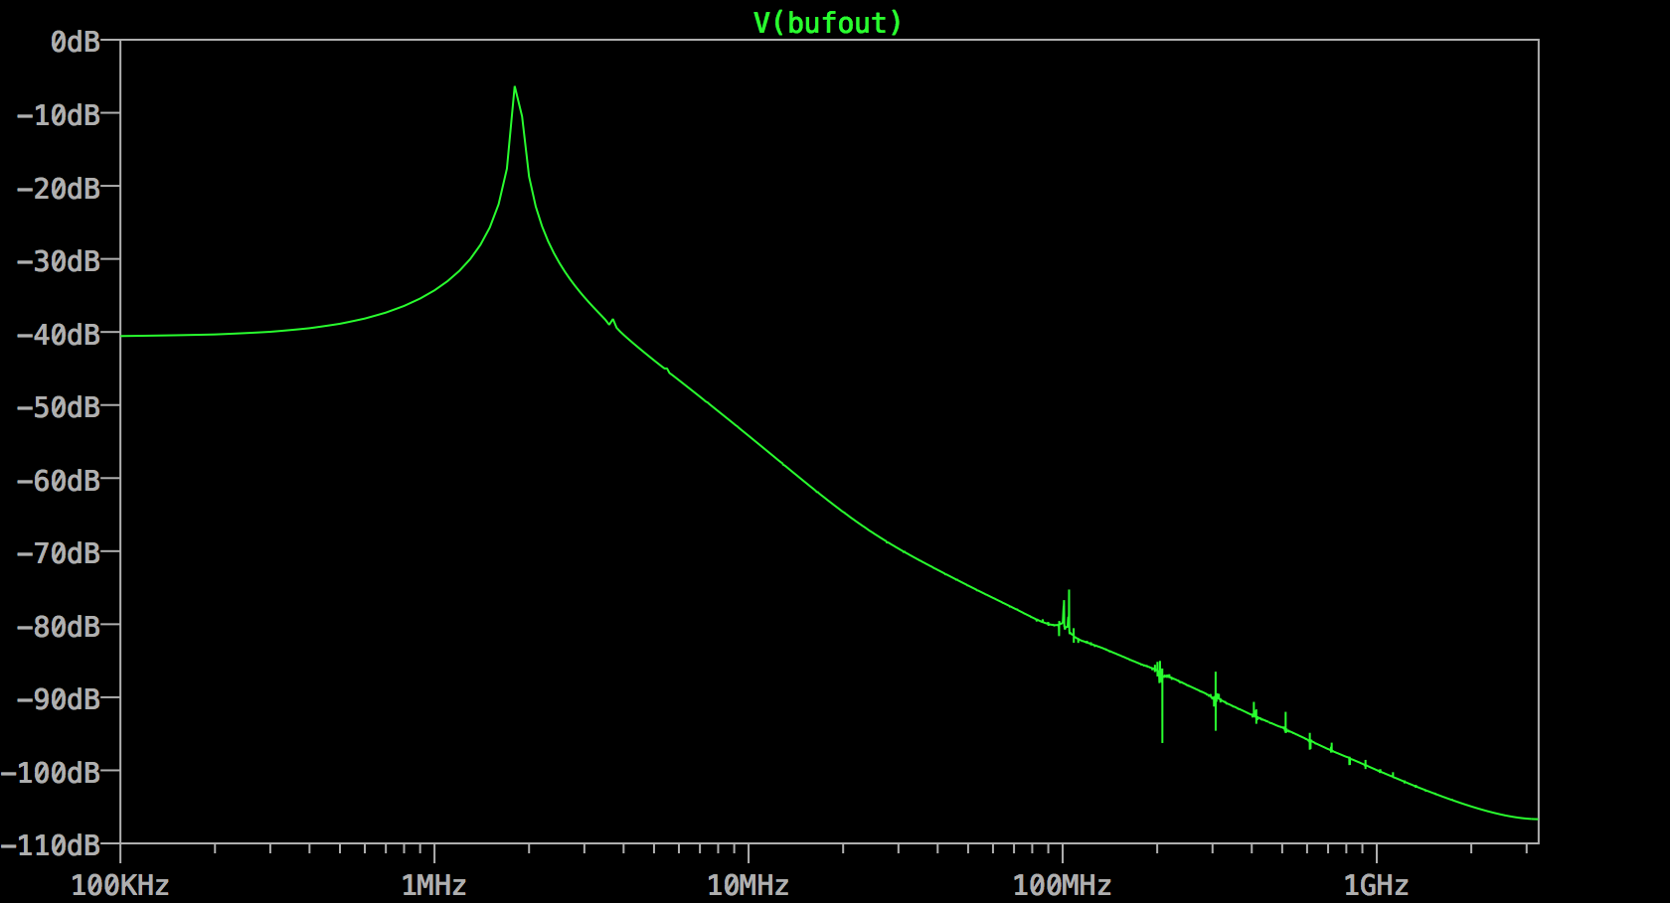

3.56MHz

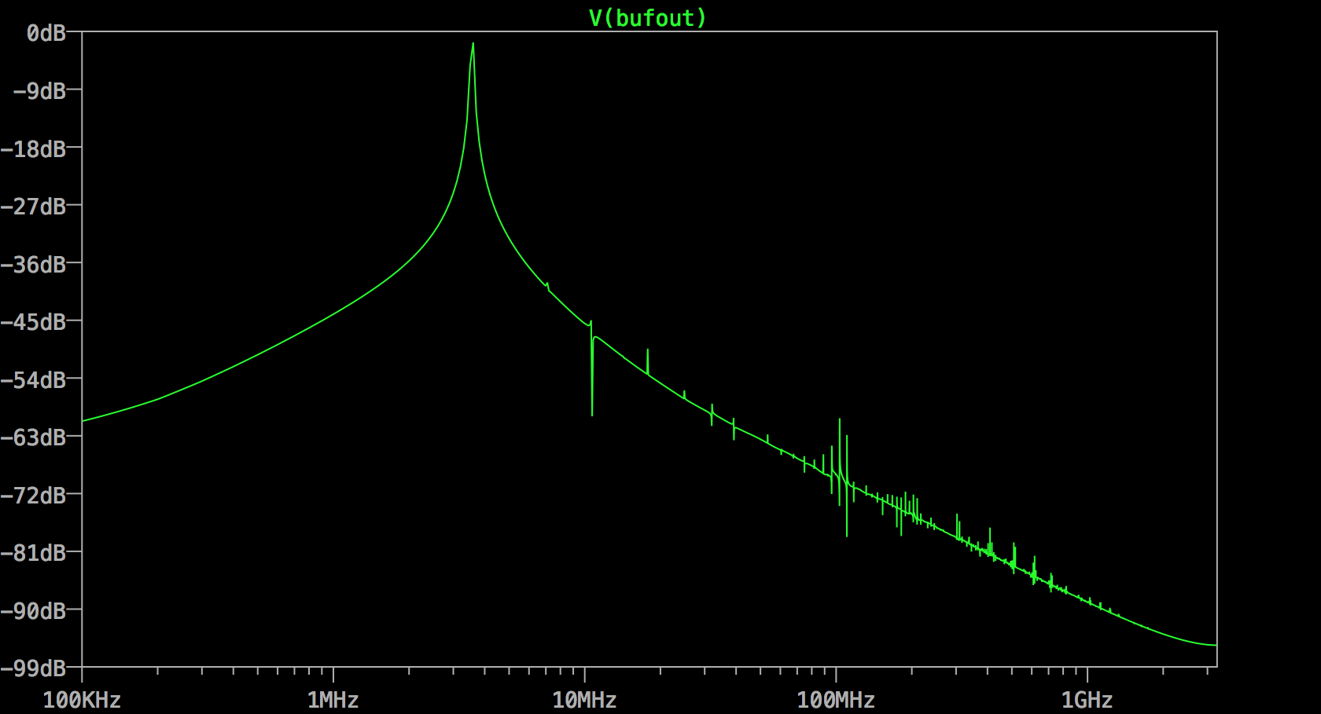

3.56MHz
10pF (.tran 100u): 232mdB – crap!
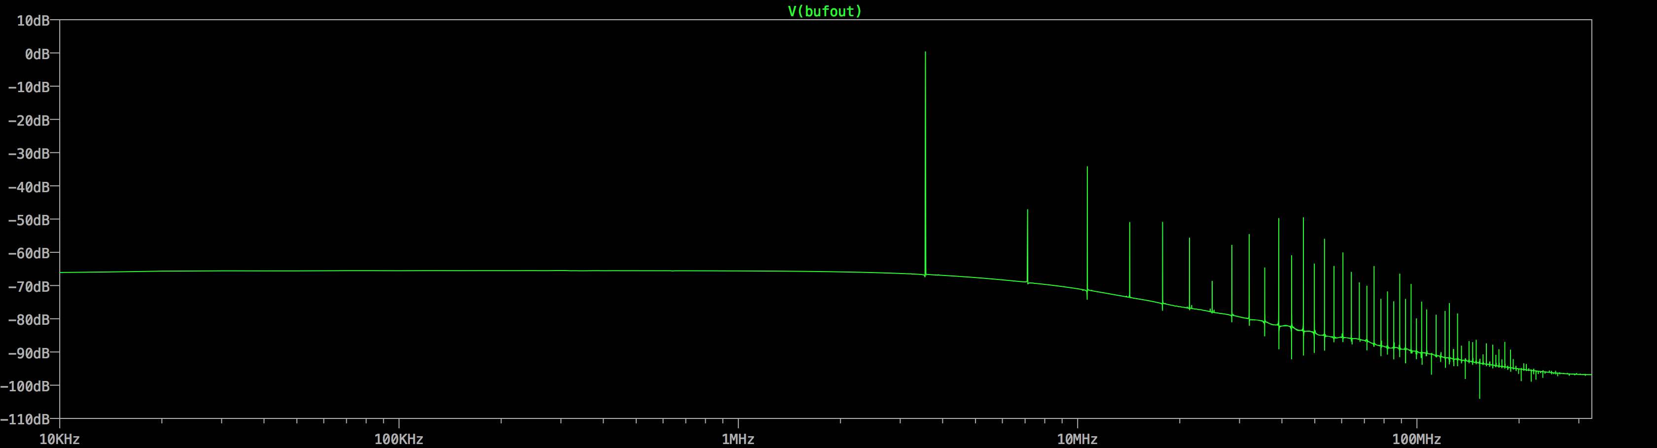
22pF (original) (.tran 100u): 6.550dB
The spectrum looks fine, and has decent signal.
